A Low-Cost Paper-Based Renal Function Screening Strip for
Medication Safety Monitoring in Elderly Patients
µPAD-Based Creatinine Detection Integrated with a Drug-Interaction Alert System (Dawai-Check)
[Your Name] | [Institution / Department] | Biotechnology

1. Problem Statement — Scale of the Burden
Chronic kidney disease has quietly become one of the fastest-growing non-communicable diseases globally, and its intersection with medication safety in the elderly is a largely unaddressed monitoring gap.
- Global CKD prevalence has more than doubled since 1990, now affecting nearly 800 million people worldwide, with a 2023 global age-standardized prevalence around 14% among adults 20 and older. South Asia carries one of the highest regional burdens at 15.8% prevalence, and China and India together account for roughly 290 million cases (152 million and 138 million respectively) — the two largest national burdens in the world.
- CKD is now the ninth-leading cause of death globally, killing nearly 1.5 million people in 2023, with mortality rates still rising even as most other leading causes of death decline.
- A GBD 2021 analysis focused on adults 75+ found that while raw prevalence held roughly steady, incidence, mortality, and disability-adjusted life years (DALYs) from CKD all rose significantly between 1990 and 2021 — age is the dominant driver of disease burden growth.
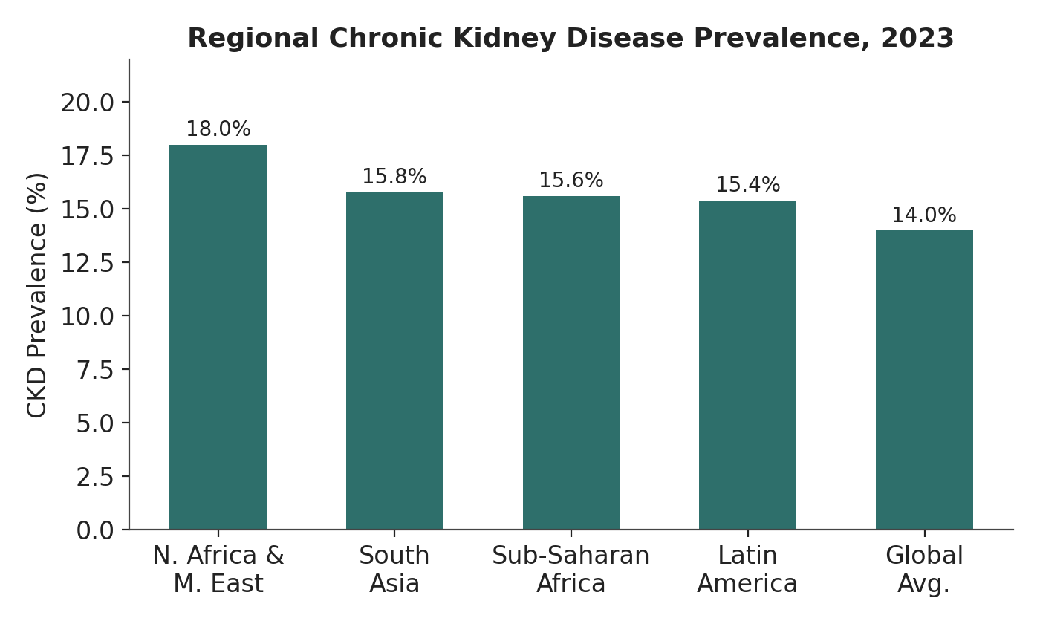
Figure 1. Regional CKD prevalence, 2023 (GBD / IHME data).
India's demographic exposure is compounding this problem. India's elderly population (60+) currently stands at around 153 million and is projected to reach 347 million by 2050, and the population aged 75+ specifically is expected to grow 340%. By 2030, older adults are projected to account for nearly 45% of India's total disease burden — a population increasingly dependent on multi-drug regimens with no routine renal re-screening between visits.
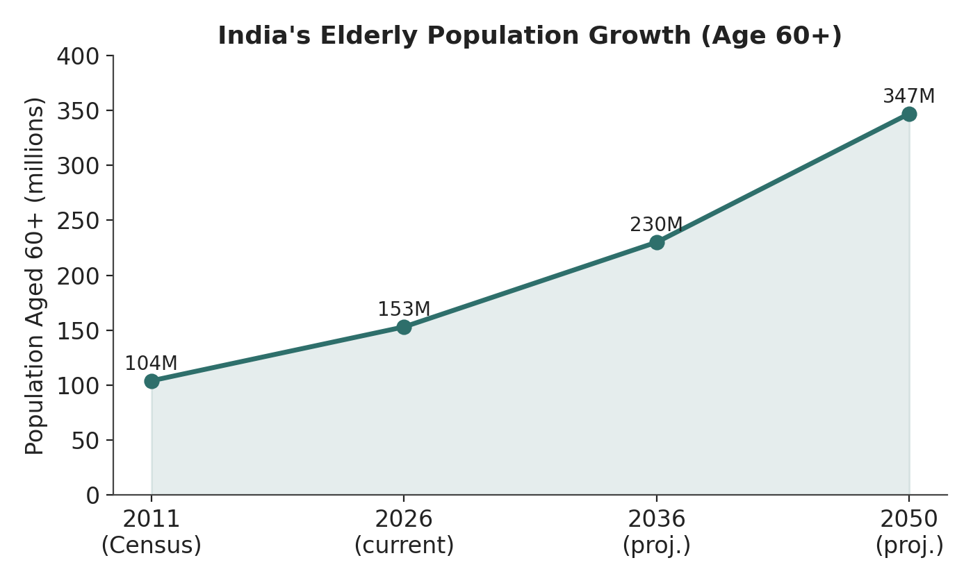
Figure 2. India's elderly population (age 60+) growth trajectory, 2011–2050 (UNFPA / Census / TGPP projections).

The Medication Side of the Risk
- Drugs cause roughly 20% of all community- and hospital-acquired acute renal failure episodes, and among older adults specifically, the incidence of drug-induced nephrotoxicity may run as high as 66%.
- A pooled meta-analysis across 302,000+ patients found an 18% incidence of acute kidney injury among patients on polypharmacy (≥5 medications), with high medication burden, nephrotoxic agents, and pre-existing renal impairment as the leading risk factors.
- Drug-induced nephrotoxicity is now recognized as one of the primary drivers of rising AKI incidence in the elderly, driven by the combination of age-related renal vulnerability and increasing medication exposure.
- In a prospective elderly-outpatient cohort, over 60% were on 5+ medications, and ADR rates climbed to 46% in patients on 9+ drugs and 39% in patients aged 80+.
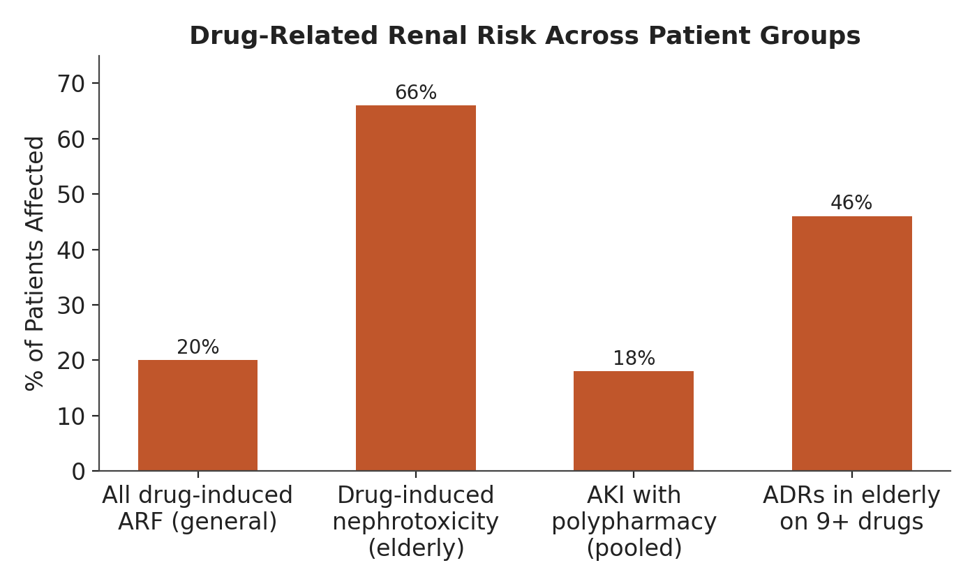
Figure 3. Drug-related renal risk across patient groups (AFP; Springer Drugs & Aging; pooled meta-analysis).
The core gap: none of this risk is caught between clinic visits. Serum creatinine testing requires a lab draw, a visit, and a turnaround time — so a patient's renal decline can silently outpace their prescription for months.

2. Scientific Rationale & Prior Art
The core chemistry is well validated in the analytical literature — this project's contribution is translating it into a caregiver-usable, decision-support-linked format.
- Several peer-reviewed groups have already built µPADs for urinary creatinine using the Jaffé reaction (creatinine + alkaline picrate → an orange-red complex), read out with ImageJ or a bench scanner. One validated device reported a linear detection range of 0.2–1 mM with a limit of detection of 0.08 mM, in good agreement with the standard Jaffé method.
- A related µPAD platform extended this to simultaneous detection of creatinine and uric acid on the same strip using separate colorimetric channels, improving diagnostic context in a single test.
- Smartphone-based colorimetric readout using HSV/hue-channel image analysis has been demonstrated for Jaffé-based creatinine sensors, achieving detection ranges around 0.33–5.65 mg/dL with an LOD of 0.25 mg/dL — validating the phone-based quantification step in this design.
- A fully disposable, wax-free µPAD variant has brought consumable cost down to about $0.40 per test using a layered filter-paper/plastic-pouch vertical-flow design, reinforcing that the ₹20–50 cost target is realistic and consistent with published low-cost devices.
What's missing from the existing literature: every one of these devices stops at the analytical step — a lab-grade quantification method demonstrated on bench equipment (ImageJ, scanners, custom optics). None of them close the loop to clinical decision-making at the point of care. That's the specific gap this project addresses by pairing the strip with Dawai-Check, a medication-risk cross-reference layer that turns a raw creatinine estimate into an actionable "safe / monitor / refer" flag against the patient's actual drug list.

3. System Design

Fabrication (µPAD)
- Filter paper cut into strips; wax-printed (or candle-wax-stamped) hydrophobic barrier defines the test zone — consistent with standard µPAD fabrication methods in the literature.
- Picric acid + NaOH reagent spotted into the zone and air-dried to create a stable, shelf-stable active spot.
- Urine sample applied → Jaffé reaction develops an orange-red complex proportional to creatinine concentration within 1–2 minutes.

Readout & Decision Layer
- Color compared to a printed reference chart, or scanned via a smartphone app using HSV/hue-based quantification, following the validated approach used in Jaffé-reaction paper sensors.
- Estimated creatinine/eGFR band logged into Dawai-Check, which cross-references it against the patient's current medication list (metformin, NSAIDs, nephrotoxic antibiotics, RAAS blockers, etc.) and flags drugs that may now require dose adjustment or physician review.

4. Validation Plan (Proposed Methodology)
- Analytical validation: calibration curves against known creatinine standards (0.2–1 mM range, matching prior µPAD literature), with LOD/LOQ determination and comparison to enzymatic/IDMS-traceable reference methods (the current clinical gold standard, given known bias in uncompensated Jaffé assays).
- Clinical concordance study: paired strip vs. lab serum/urine creatinine on real patient samples, Bland-Altman and correlation analysis, sensitivity/specificity for flagging eGFR <60 mL/min/1.73m².
- Reproducibility: inter-strip, inter-batch, and inter-reader (human eye vs. app) variability testing.
- Human factors: usability testing with actual caregivers (not clinicians) to validate the color-chart/app workflow under real home conditions.

5. Cost-Effectiveness Positioning
Approach | Cost / test | Turnaround | Setting
Standard lab serum creatinine | ₹150–400+ | 1–2 days | Hospital / lab only
Published disposable µPAD (literature) | ~₹35 (~$0.40) | 1–2 min | Bench / lab-adjacent
This device + Dawai-Check | ₹20–50 | 1–2 min | Home, caregiver-operated
The novelty isn't a cheaper chemistry — it's collapsing lab-grade turnaround into a home-usable loop that already exists in published analytical devices, and closing it with a medication-safety decision layer that doesn't exist in any published µPAD work to date.

6. Safety & Regulatory Note
Dry picric acid is a mild explosive-risk controlled reagent — all reagent preparation and strip manufacturing must occur under controlled lab conditions with appropriate storage/handling protocols; this is a manufacturing-stage constraint, not a home-use hazard once strips are dried, stabilized, and packaged.

7. Future Directions
- Enzymatic-based alternative reagent chemistry to reduce reliance on picric acid at the manufacturing stage.
- Expansion of Dawai-Check's drug-risk database and integration with India's Ayushman Bharat digital health records.
- Prospective field trial in a home-care/geriatric population to validate real-world adherence and outcome impact.

References
1. Microfluidic Paper-based Analytical Devices for Determination of Creatinine in Urine Samples. Analytical Sciences, 2018.
2. Rossini, E.L., Milani, M.I., Carrilho, E., Pezza, L., Pezza, H.R. Simultaneous determination of renal function biomarkers in urine using a validated paper-based microfluidic analytical device. Anal Chim Acta, 2018;997:16-23.
3. Disposable Microfluidic Paper-Based Device for On-Site Quantification of Urinary Creatinine. Chemosensors, 2023;11(7):368.
4. Colorimetric detection of serum creatinine on a miniaturized platform using hue-saturation-value space analysis. Scientific Reports, 2024.
5. Institute for Health Metrics and Evaluation (IHME). Chronic kidney disease has more than doubled since 1990, now affecting nearly 800 million people worldwide. GBD 2023 Study, 2025.
6. Global, Regional, and National Burden of chronic kidney disease in older adults from 1990 to 2021: Results from the Global Burden of Disease Study 2021. PLOS One / PMC, 2026.
7. GBD Chronic Kidney Disease Collaboration. Global, regional, and national burden of chronic kidney disease, 1990–2017: a systematic analysis for the Global Burden of Disease Study 2017. Lancet.
8. Drug-Induced Nephrotoxicity. American Family Physician (AAFP), 2008;78(6):743-750.
9. Drug-Induced Kidney Injury in the Elderly. Drugs & Aging, Springer Nature, 2017.
10. Incidence and risk factors of acute kidney injury in patients with polypharmacy: a systematic review and meta-analysis. International Journal of Clinical Pharmacy, 2025.
11. A Single-Center Prospective Study on Adverse Drug Reactions Associated With Polypharmacy in Elderly Outpatients. PMC, 2025.
12. United Nations Population Fund (UNFPA) India. India's Ageing Population: Why It Matters More Than Ever / India Ageing Report 2023.
13. Ministry of Health and Family Welfare, Government of India. Elderly in India / Population Projection Report (TGPP), 2020.

